Juice production line
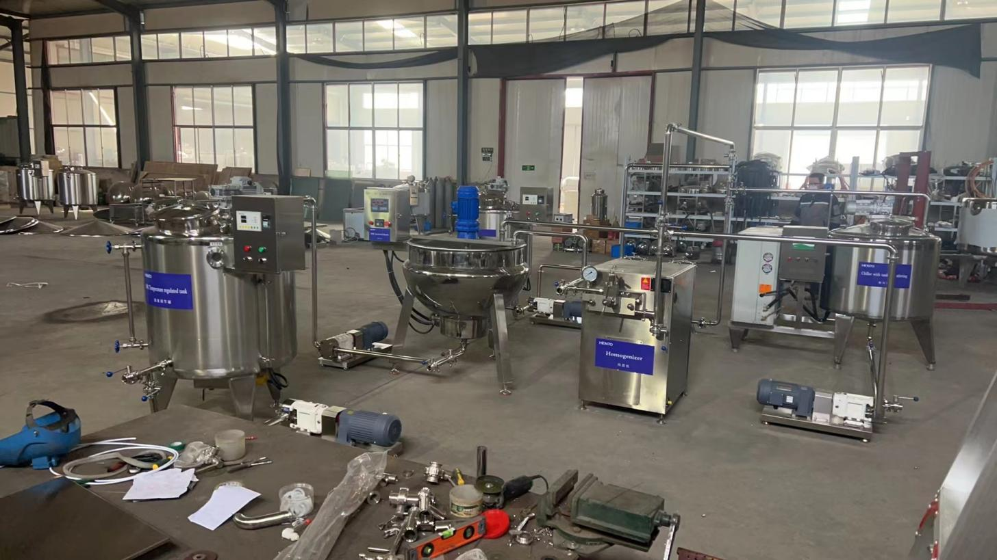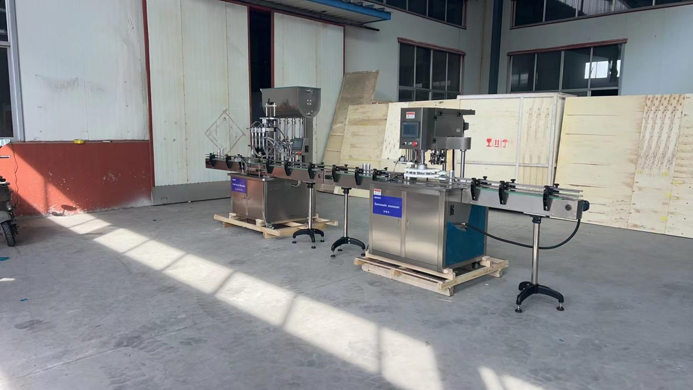
Item No. | Item | QTY
1 | Liquid tank (300L) with proper Mixing function + VSD + Level meter (heating+stirring+storage) | 1
2 | High viscosity liquid transfer pumps /3000LpH | 1
3 | SS mesh Double Filter Unit (0.25 microns) / 500LpH | 1
4 | Chiller Tank (300L) with stirring function / Operating Temp 4'C~27'C / 300L | 1
5 | Jacketed Kettle (300L) with Mixing function + VSD / Max Operating Temp 95'C | 1
6 | Temperature regulated Heated tank (300L) with stirring function / 300L / 85'C | 1
7 | Automatic Hot Filling with 04 nozzles /Operating Temp 85'C / 25BpM / with Conveyor | 1
8 | Automatic Can Seamer / 2000CpH / Adjustable head for 250ml / 330ml / 500ml | 1
9 | Manual lug Capping machine (38mm) / Adjustable head / 30BpM | 1
10 | Fully Automatic Horizontal Electric Retort with Control panel and Temperature, Time, and Pressure display / 600 bottles (370ml) | 1
11 | Sticker labelling machine - Manual | 1
12 | Liquid Transfer SS Pump | 1
13 | Fruit Juice extractor | 1
14 | Fruit Pulping machine | 1

◆. Remark
◆.Manufacturing Time: 15 days after get customers' payment.
◆.Payment term: T/T payment, Western union, Escrow.
◆.Valid time: This quotation is valid for one month.
◆.Quality Guarantee Terms:
Quality guarantee term is for two years. Malfunctions which are caused by machine-self and quality will be responsible for our manufacturer. Other malfunctions which are caused by operation mistakes, man-made problems, etc will be responsible for clients-self.

